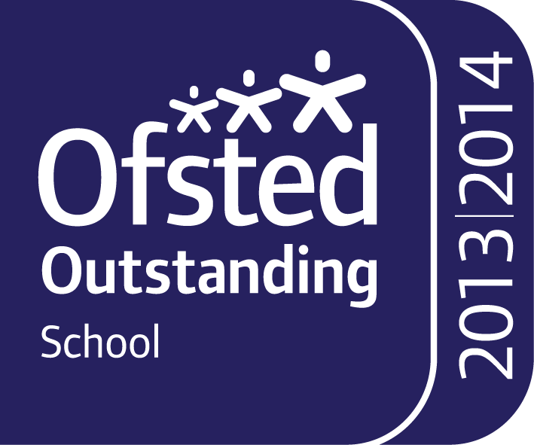



Behaviour For Learning Policy

DATE: September 2021

Date for Review: September 2022

Introduction/Rationale
Our school values of respect, responsibility and resilience are embedded in everyday life at Brampton Ellis Primary School. This policy aims to provide a consistent approach to behaviour management in our school. Key documents and legal framework have been used to create this policy, including the report from the Education Endowment Foundation on Improving Behaviour in Schools and will focus on 6 main points:
- Know and understand your pupils and their influences
- Teach learning behaviours alongside managing misbehaviour
- Use classroom management strategies to support good classroom behaviour
- Use simple approaches as part of your regular routine
- Use targeted approaches to meet the needs of individuals in your school
- Consistency is key

Legal framework
This policy has due regard to statutory legislation, including, but not limited to, the following:
- The Education Act 2011
- The Equality Act 2010
- The Education and Inspections Act 2006
- The Health Act 2006
- The School Information (England) Regulations 2008, and the amendments made in 2012 (as
- amended)
This policy also has due regard to DfE guidance, including, but not limited to, the following:
- DfE ‘Behaviour and discipline in schools’ 2016
- DfE ‘Keeping Children Safe in Education’ 2021

1. Know and understand your pupils and their influences
It is important at Brampton Ellis that positive relationships with children are at the forefront of behaviour management. Using a method of “Establish, Maintain, Restore”, we aim to ensure that behaviour is managed in a respectful and effective way. Every child is unique and the steps below will ensure that staff have the right tools in place to find practices that work for a wide range of children.
All staff will:
- Use intentional practices to build a positive relationship with each pupil (establish)
- Make a proactive effort to prevent relationships from diminishing over time (maintain)
- Intentionally repair harm to the relationship after a negative interaction (restore)
This will include;
- Positive communications
- Inquiry about children’s interests
- Open ended questions
- Reflective listening
- Positive notes home
- In class rewards such as Dojo points
- Greet students pleasantly
- Give statements of empathy
- Let go of previous incidents and offer fresh starts
- Engage in mutual problem solving

2. Teach learning behaviours alongside managing behaviour
All children don’t know how to behave appropriately. Learning behaviours need to be taught explicitly and modelled to students. Teaching of learning behaviours can be delivered by focusing on one or more of three main aspects; relationship with self, relationship with curriculum and relationship with others.
To promote and teach these skills, all staff will develop:
- relationship with self
  - discuss how they have felt when experiencing set backs
  - listen to the concerns of the pupil
  - promote self-esteem and motivation
  - praise the child’s efforts rather than the end product (e.g. you have worked so hard on this)
  - self-regulation
- relationship with curriculum
  - ensure that pupils have appropriately levelled work that will lead to the experience of success when completed
  - praise pupils for persevering
- relationship with others
- create a classroom culture where pupils are proud to say they found a task difficult
- create a classroom culture where children collaborate and learn from others
- create a classroom culture where pupils are not afraid to get things wrong

3. Use classroom management strategies to support good classroom behaviour
A central part of whole classroom management is a clear and consistent praise and consequence system. At Brampton Ellis we believe strongly that positive behaviour should be praised. Where necessary consequences should be given that are appropriate to the age and needs of the child.
General classroom strategies used on a day to day basis:
- ensure every lesson is well organised and that there is no 'downtime'
- use of classroom checklist (see appendix) to ensure preparedness
- build in appropriate challenge- every child needs to feel successful
- develop smooth transitions
- establish clear routines
- consider the use of a class charter
- develop 'de-escalation' and distraction strategies to nip any potential inappropriate behaviour in the bud
- use peer praise

Extrinsic motivation rewards that may be used are:
- Dojo points
- Prizes
- Treat sessions (e.g. extra play, film at end of term)

For consequences staff will:
- Remind of expected behaviour, then;
- Give warning of consequences, then;
- Selective use of consequence such as
  - Time out/reflection time
  - De-escalation techniques
  - loss of playtime
  - time spent with SLT
  - phone call home

4. Use simple approaches as part of your regular routine
It is imperative to note that behaviour management is not just implemented when a child is behaving in a negative way. Any adult needs to ensure that their regular routines include the measures such as those mentioned above throughout the day.
We like to use the phrase “pick up on positives” at BEP and this reflects the model of 5:1 ratio. In the 5:1 model, for every issue that the adult raises they should aim to give 5 specific compliments, approval statements, positive comments or non-verbal gestures. This model aims to reinforce positive behaviours and maintain the relationship between child and adult.

5. Use targeted approaches to meet the needs of individuals in your school
Universal systems are unlikely to work for all children. Where our normal strategies have been implemented and we still see challenging behaviour from individual children, we may seek advice from outside agencies. This can vary from the Aspire Outreach team, Inclusion Support Services and the Educational Psychologist. Advice from these professionals can more closely guide adults in school with specific strategies tailored to the child. These strategies would be delivered as targeted interventions with regular reviews held between family, school and the agency using a child centred approach to guide next steps, documented with a support plan.

6. Consistency is key
Perhaps the most important tool of them all is consistency. Brampton Ellis Primary is a large school and throughout their time with us, children here will encounter many adults. It is important that as they move through school, children see that we are consistent with what we say and do in both praise and consequences. Establishing, maintaining and restoring relationships with our children is vital to the success of positive behaviour in school and this can only be achieved through a consistently used approach.

Exclusions
In cases of exclusions, whether it is internal, fixed-term or permanent, JMAT’s Exclusion Policy will be followed at all times. In the event of any type of exclusion, the Headteacher or the rest of the SLT will inform the pupil’s parents/carers of the exclusion, which outlines the nature of the incident, the exclusion duration and any alternative provision supplied. The decision to exclude a pupil is invariably done on the grounds that the pupil’s behaviour constitutes such a breach of school conduct that other disciplines are not sufficient. In the absence of the Headteacher, the deputy headteacher will make the decisions concerning a pupil’s exclusion. The Headteacher has the ability to permanently exclude a pupil who has seriously breached the school’s Code of Conduct, or who is a persistent offender. Permanent exclusions will be considered by the governing body for authorisation. The exclusion process outlined in the Exclusion Policy, will be followed at all times, ensuring that parents/carers are suitably informed and are made aware of their right to appeal.

Monitoring, Evaluation and Policy review
The policy will be promoted and implemented throughout BEP. This policy will be assessed for its implementation and effectiveness annually by the Headteacher and the SENDCo.

Appendix

1. Classroom Checklist
Adults should consider their preparedness for the children in their classroom. Using a checklist such as The Inclusive Classroom Checklist, adults can identify if they have created a space that allows pupils to be successful. For example:
- The Room
  - Can the children see what they need to see? (teacher/board/learning materials)
- Relationships
  - Does every vulnerable child have a go-to trusted adult they can turn to?
  - Do you know how to respond to the SEMH needs of the children in your classroom?
- Resources
  - Have you discussed resources with the children? Do they know how to use them?
  - Children who need resources for access to reading and writing, are these readily available and prepared?
- Relevance
  - How well do you adapt the curriculum to your children?
  - How far does the learning and curriculum relate to the children’s own experiences?
- Response
  - Are children encouraged to share their ideas in different ways, including the use of technology?
  - Are instructions and guidance differentiated to different children?
- Recall
  - Do you use questioning and a variety of prompts to support children in recalling and applying their learning
- Retention
  - … (more on topic of learning that general classroom strategies but can put it in if needed)
- Resilience
  - Are children supported to feel okay to try and fail and then feel confident enough to try again?
  - How far does the teacher feedback enable children to identify and celebrate success, rather than just identify areas for development

