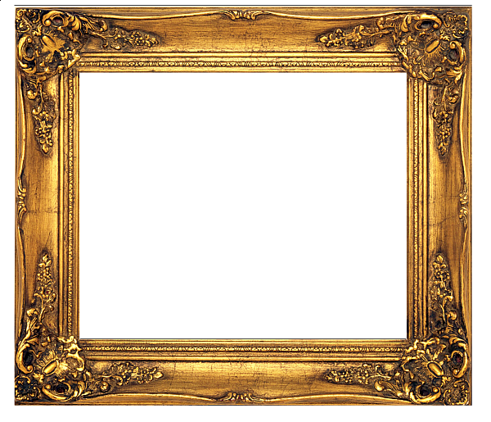

**Art Competition July 2021: FREEDOM**

At Brampton ‘The Ellis’ Primary School, we believe that art stimulates creativity, imagination and inventiveness. We believe that art gives our pupils the skills, concepts and knowledge necessary for them to express responses to ideas and experiences.

After a difficult year of COVID-19 restrictions, we have decided to have an art competition for the children to explore and express themselves through drawing, painting and/or sculpture with the theme of FREEDOM.

This will take place in school over the summer term and the winners will receive a winners' magazine showcasing their work. Work from FS1-Year 6 will be displayed throughout the whole school in September.

We look forward to seeing the children practising their artistic skills and expressing their creativity.

Watch this space for the winners in July!